**Task#01 – Basic SQL -Run the following queries:**

1. Write a query that returns all the orders where the standard_qty is over 1000, the poster_qty is 0, and the gloss_qty is 0.

**OUTPUT:**

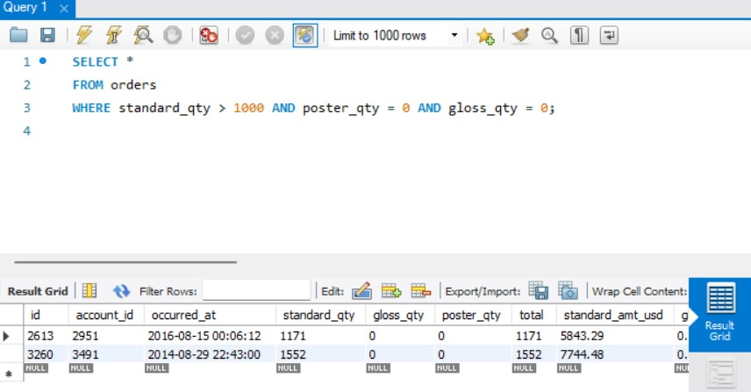

1. Using the accounts table find all the companies whose names do not start with 'C' and end with 's'.

**OUTPUT:**

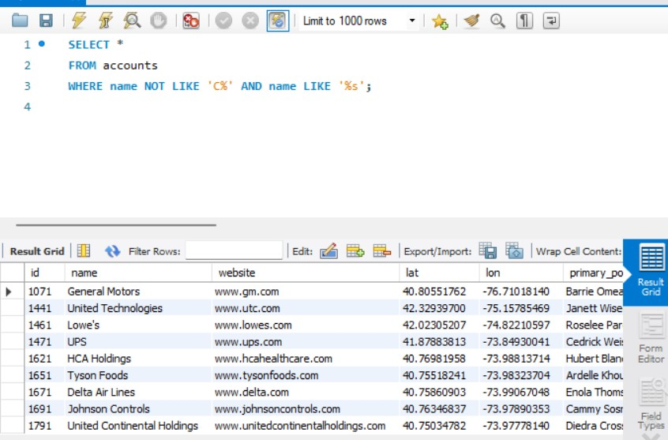

1. Use the web_events table to find all information regarding individuals who were contacted via organic or adwords and started their account at any point in 2016 sorted from newest to oldest.

**OUTPUT:**

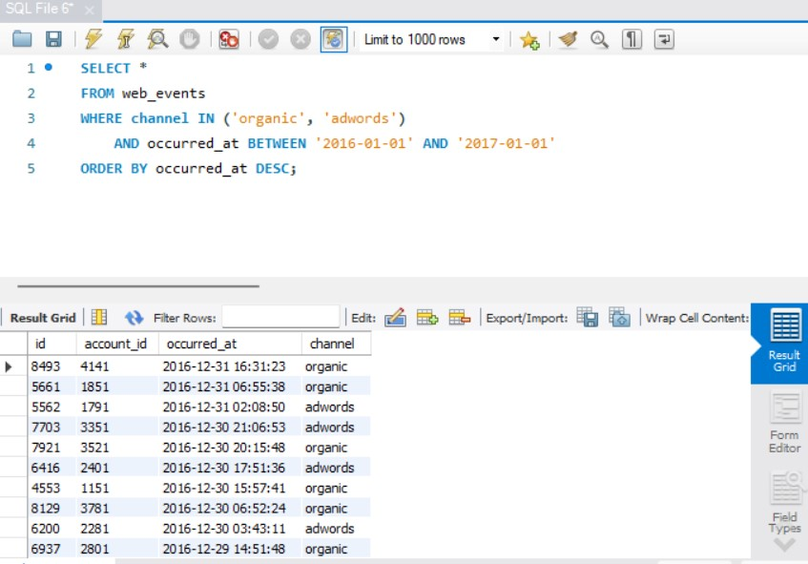

**Task#02 – Joins -Run the following queries:**

1. Provide a table that provides the **region** for each **sales_rep** along with their associated **accounts**. This time only for the Midwest region. Your final table should include three columns: the region **name**, the sales rep **name**, and the account **name**. Sort the accounts alphabetically (A-Z) according to account name.

**OUTPUT:**

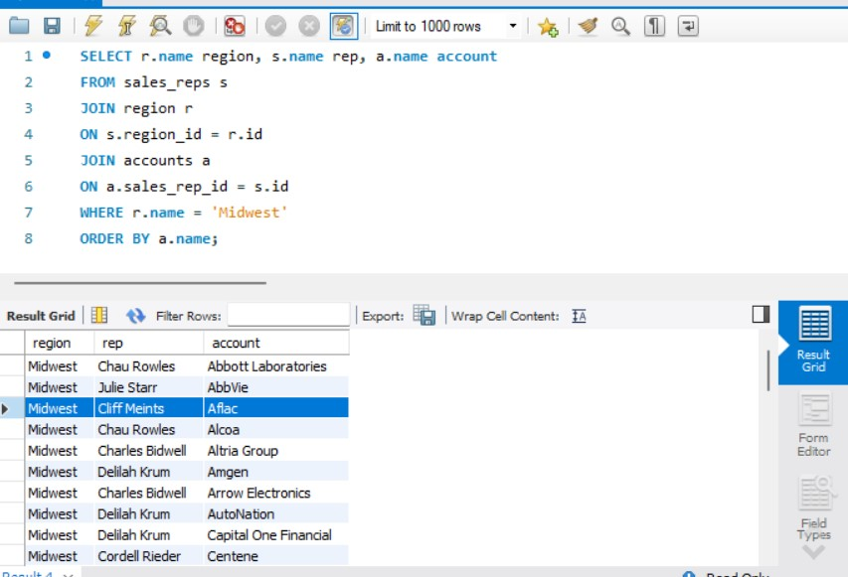

1. Provide a table that provides the **region** for each **sales_rep** along with their associated **accounts**. This time only for accounts where the sales rep has a first name starting with S and in the Midwest region. Your final table should include three columns: the region **name**, the sales rep **name**, and the account **name**. Sort the accounts alphabetically (A-Z) according to account name.

**OUTPUT:**

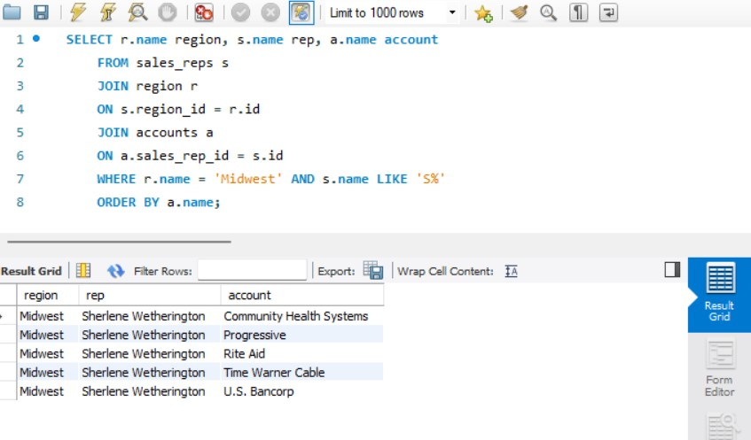

1. Provide a table that provides the **region** for each **sales_rep** along with their associated **accounts**. This time only for accounts where the sales rep has a **last** name starting with K and in the Midwest region. Your final table should include three columns: the region **name**, the sales rep **name**, and the account **name**. Sort the accounts alphabetically (A-Z) according to account name.

**OUTPUT:**

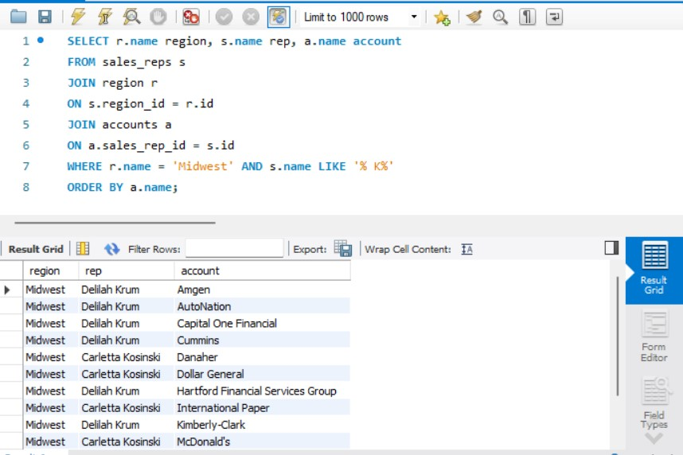

**Task#03 – SQL Aggregations -Run the following queries:**

1. Find the total amount spent on **standard_amt_usd** and **gloss_amt_usd** paper for each order in the orders table. This should give a dollar amount for each order in the table.

**OUTPUT:**

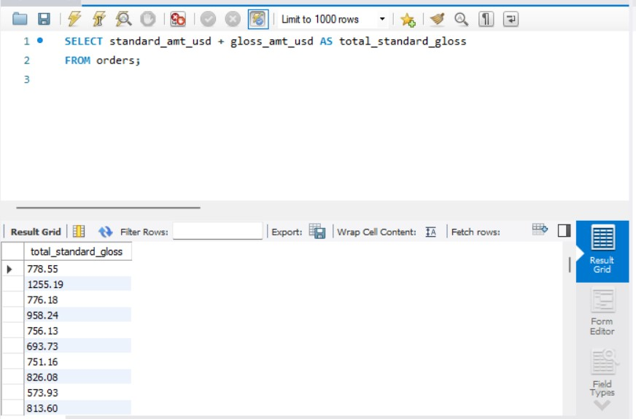

1. Find the mean (**AVERAGE**) amount spent per order on each paper type, as well as the mean amount of each paper type purchased per order. Your final answer should have 6 values - one for each paper type for the average number of sales, as well as the average amount.

**OUTPUT:**

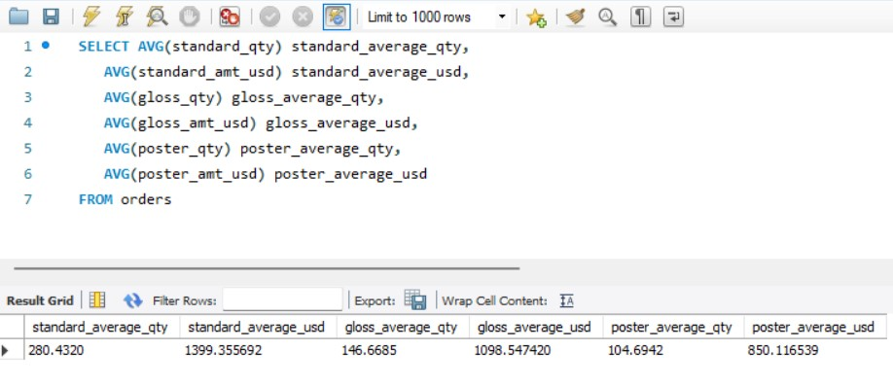

1. Which account used facebook most as a **channel**?

**OUTPUT:**

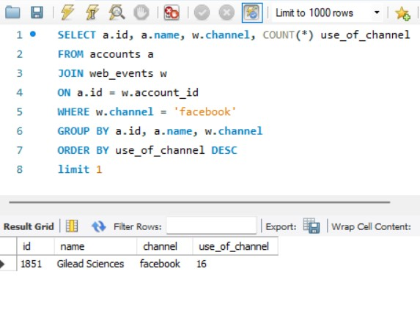

**Task#04 –SQL Subqueries-Run the following queries:**

1. Use **DATE_TRUNC or EXTRACT** to pull month level information about the first order ever placed in the **orders** table.

**OUTPUT:**

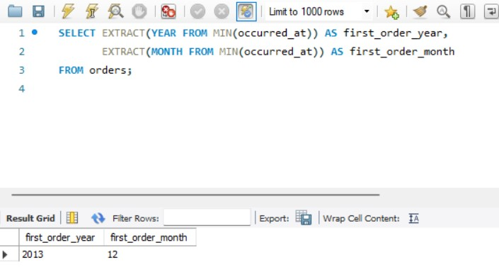

**Task#05 –SQL Data Cleaning -Run the following queries:**

1. In the **accounts** table, there is a column holding the **website** for each company. The last three digits specify what type of web address they are using. A list of extensions (and pricing) is provided [here](https://iwantmyname.com/domains/domain-name-registration-list-of-extensions). Pull these extensions and provide how many of each website type exist in the **accounts** table.

**OUTPUT:**

